**AIRLINE RESEVATION SYSTEM**

**ABOUT**

We made an airline reservation system by using the C++ LANGUAGE.

**FUNCTIONALITY**

In this reservation system we made for classes.

**1) Booking flights**

**2) Cancel flights**

**3) Check tickets**

**4) Exit program**

**In the first class** we make bookings .In the booking we book our flights by giving out the dates. We have two options in the first class. We have separated the class into two options flights, one is domestic flight and one is international flight. Whichever fight we want to choose we will choose it. After that we will choose the flight destination where we want to go after that we will select the date on which we want to go. After choosing date we will choose the destination of the flight.

**In the second class** we have two options to modify and cancel the flights. We can also change the flights and we can also cancel our ticket. The reservation system will show us that if the flight is available for your flight or not.

**Third class uses switches** .in the third class we can choose the ticket the ticket value and also if the ticket is refundable.

**4th class of the reservation system is to exit** if we want to exit the program we can do that from there.

**ADVANTAGES**

The uses of airline reservation system include:

There **is 24/7 booking option** for the customers by using airline reservation system.

We can increase **the efficiency** of the system.

We can book tickets and check the prices and the **business can be monitored through any location.**

It shows **the real time of date** on the screen.

**It increases the profit** by eliminating the agents and directly providing services to the travelers or the passengers.

**We can fully customized and you can pre** book the flight or you can also get some discount on your flight we can easily cancel the flight.

We can easily customize our flights and we can easily book the tickets and also if we cancel, we can also get the refund over the flight.

**Screenshots**

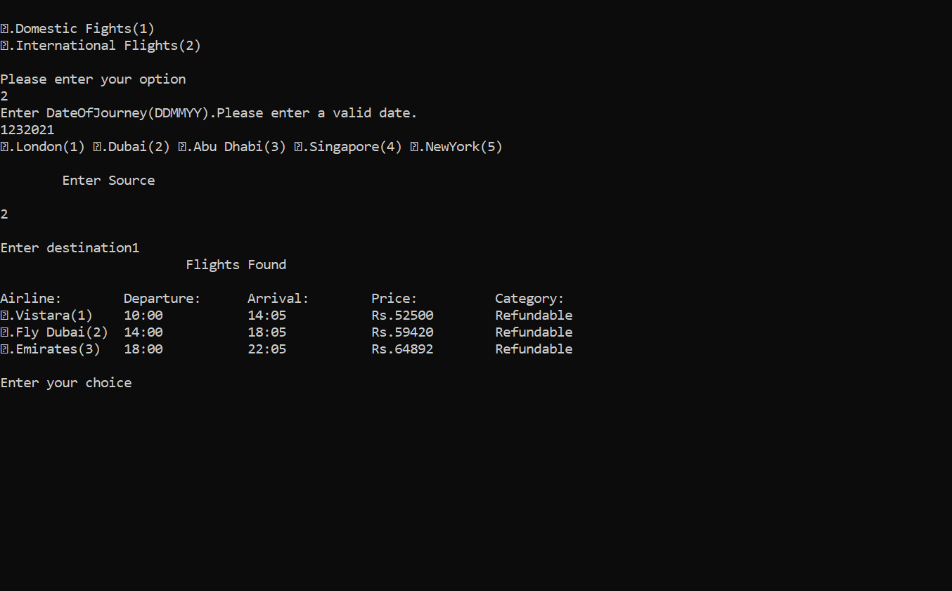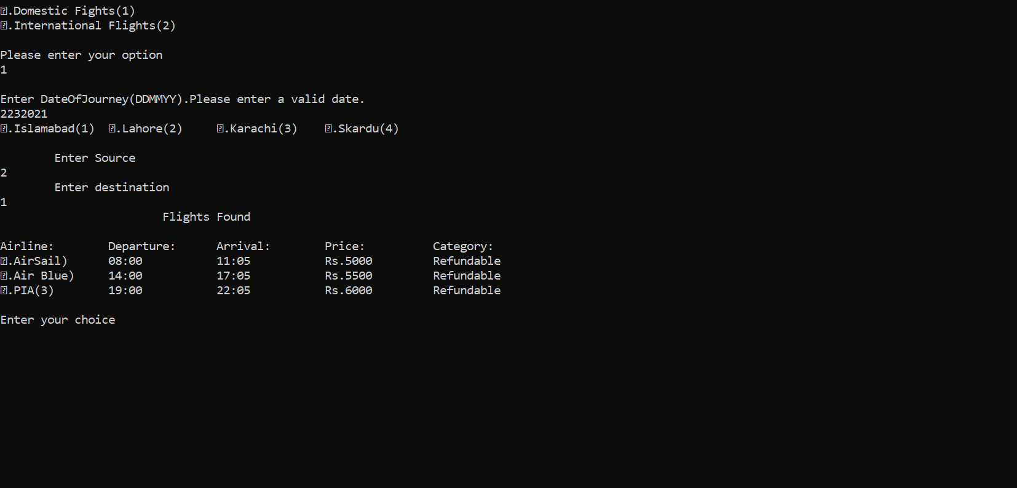

**CODE**

#include <iostream>

#include<fstream>

#include<string.h>

using namespace std;

int glob=0;

int global=10;

class d_booking

{

protected:

int pnr;

char f_d[10],toja[7],tojd[7];

long int doj;

int choice,src,dest;

public:

void d_pnr()

{

glob++;

pnr=glob;

}

int j_detail()

{

cout << "\nEnter DateOfJourney(DDMMYY)." << "Please enter a valid date." << endl;

cin >> doj;

cout << "\1.Islamabad(1) \t\2.Lahore(2) \t\3.Karachi(3) \t\4.Skardu(4)" << endl << endl;

cout << "\tEnter Source" << endl;

cin >> src;

cout << "\tEnter destination" << endl;

cin >> dest;

if((src==1 && dest==2) || (src==2 && dest==1))

{

cout << "\t \t \tFlights Found" << endl << endl;

cout << "Airline:\tDeparture:\tArrival:\tPrice:\t\tCategory:\n";

cout << "\1.AirSail)\t08:00\t\t11:05\t\tRs.5000\t\tRefundable\n";

cout << "\2.Air Blue)\t14:00\t\t17:05\t\tRs.5500\t\tRefundable\n";

cout << "\3.PIA(3)\t19:00\t\t22:05\t\tRs.6000\t\tRefundable\n";

}

else if((src==1 && dest==3) || (src==3 && dest==1))

{

cout << "\t \t \tFlights Found" << endl << endl;

cout << "Airline:\tDeparture:\tArrival:\tPrice:\t\tCategory:\n";

cout << "\1.AirSial)\t08:00\t\t11:05\t\tRs.5000\t\tRefundable\n";

cout << "\2.Air Blue(2)\t14:00\t\t17:05\t\tRs.5500\t\tRefundable\n";

cout << "\3.PIA(3)\t19:00\t\t22:05\t\tRs.6000\t\tRefundable\n";

}

else if((src==1 && dest==4) || (src==4 && dest==1))

{

cout << "\t \t \tFlights Found" << endl << endl;

cout << "Airline:\tDeparture:\tArrival:\tPrice:\t\tCategory:\n";

cout << "\1.AirSail)\t08:00\t\t11:05\t\tRs.4000\t\tRefundable\n";

cout << "\2.Air Blue(2)\t14:00\t\t17:05\t\tRs.4250\t\tRefundable\n";

cout << "\3.PIA(3)\t19:00\t\t22:05\t\tRs.6100\t\tRefundable\n";

}

else if((src==2 && dest==3) || (src==3 && dest==2))

{

cout << "\t \t \tFlights Found" << endl << endl;

cout << "Airline:\tDeparture:\tArrival:\tPrice:\t\tCategory:\n";

cout << "\1.AirSial)\t08:00\t\t11:05\t\tRs.5400\t\tRefundable\n";

cout << "\2.AirBlue(2)\t14:00\t\t17:05\t\tRs.2500\t\tRefundable\n";

cout << "\3.PIA(3)\t19:00\t\t22:05\t\tRs.2890\t\tRefundable\n";

}

else if((src==2 && dest==4) || (src==4 && dest==2))

{

cout << "\t \t \tFlights Found" << endl << endl;

cout << "Airline:\tDeparture:\tArrival:\tPrice:\t\tCategory:\n";

cout << "\1.AirSial(1)\t08:00\t\t11:05\t\tRs.5000\t\tRefundable\n";

cout << "\2.Air Blue(2)\t14:00\t\t17:05\t\tRs.4500\t\tRefundable\n";

cout << "\3.PIA(3)\t19:00\t\t22:05\t\tRs.6000\t\tRefundable\n";

}

else if((src==3 && dest==4) || (src==4 && dest==3))

{

cout << "\t \t \tFlights Found" << endl << endl;

cout << "Airline:\tDeparture:\tArrival:\tPrice:\t\tCategory:\n";

cout << "\1.AirSial(1)\t08:00\t\t11:05\t\tRs.5800\t\tRefundable\n";

cout << "\2.Air Blue(2)\t14:00\t\t17:05\t\tRs.5508\t\tRefundable\n";

cout << "\3.PIA(3)\t19:00\t\t22:05\t\tRs.6050\t\tRefundable\n";

}

else if(src==dest)

{

cout << "\nSource and destination can't be same.\nTry again\n\n\n" << endl;

return j_detail();

}

else

{

cout <<"\nWrong input entered\nTry again\n\n\n" << endl;

return j_detail();

}

}

int select_flight()

{ cout << "\nEnter your choice" << endl;

cin >> choice;

switch(choice)

{

case 1:

cout << "\nFlight selected:"<<endl;

cout << "AirSial"<<endl;

strcpy(f_d,"AirSial");

cout << "Departure Time : 08:00"<<endl;

cout<<"Arrival Time: 11:05"<<endl;

strcpy(tojd,"8:00");

strcpy(toja,"11:05");

break;

case 2:

cout << "\nFlight selected:"<<endl;

cout << "Air Blue"<<endl;

strcpy(f_d,"Air Blue");

cout << "Departure Time : 14:00"<<endl;

cout<<"Arrival Time: 17:05"<<endl;

strcpy(tojd,"14:00");

strcpy(toja,"17:05");

break;

case 3:

cout << "\nFlight selected:" << endl;

cout << "Go Air" << endl;

strcpy(f_d,"Go Air");

cout << "Departure Time : 19:00" << endl;

cout<<"Arrival Time: 22:05" << endl;

strcpy(tojd,"19:00");

strcpy(toja,"22:05");

break;

default:

cout << "Wrong input entered.\nTry again" << endl;

return select_flight();

}

}

};

class i_booking

{

protected:

int pnri;

char f_i[10],tojai[7],tojdi[7];

long int doji;

int srci,desti,choicei;

public:

void i_pnr()

{

global++;

pnri=global;

}

int j_detaili()

{

cout << "Enter DateOfJourney(DDMMYY)." << "Please enter a valid date." << endl;;

cin >> doji;

cout << "\1.London(1) \2.Dubai(2) \3.Abu Dhabi(3) \4.Singapore(4) \5.NewYork(5) " << endl << endl;

cout << "\tEnter Source" << endl;

cin >> srci;

cout << "\nEnter destination" ;

cin >> desti;

cout << "\t \t \tFlights Found" << endl << endl;

if((srci==1 && desti==3) || (srci==3 && desti==1))

{

cout << "Airline:\tDeparture:\tArrival:\tPrice:\t\tCategory:\n";

cout << "\1.Vistara(1)\t10:00\t\t14:05\t\tRs.25000\tRefundable\n";

cout << "\2.Fly Dubai(2)\t14:00\t\t18:05\t\tRs.21500\tRefundable\n";

cout << "\3.Emirates(3)\t18:00\t\t22:05\t\tRs.24000\tRefundable\n";

}

else if((srci==1 && desti==4) || (srci==4 && desti==1))

{

cout << "Airline:\tDeparture:\tArrival:\tPrice:\t\tCategory:\n";

cout << "\1.Vistara(1)\t10:00\t\t14:05\t\tRs.25500\tRefundable\n";

cout << "\2.Fly Dubai(2)\t14:00\t\t18:05\t\tRs.21300\tRefundable\n";

cout << "\3.Emirates(3)\t18:00\t\t22:05\t\tRs.24650\t\tRefundable\n";

}

else if((srci==1 && desti==5) || (srci==5 || desti==1))

{

cout << "Airline:\tDeparture:\tArrival:\tPrice:\t\tCategory:\n";

cout << "\1.Vistara(1)\t10:00\t\t14:05\t\tRs.52500\tRefundable\n";

cout << "\2.Fly Dubai(2)\t14:00\t\t18:05\t\tRs.59420\tRefundable\n";

cout << "\3.Emirates(3)\t18:00\t\t22:05\t\tRs.64892\tRefundable\n";

}

else if((srci==2 && desti==3) || (srci==3 && desti==2))

{

cout << "Airline:\tDeparture:\tArrival:\tPrice:\t\tCategory:\n";

cout << "\1.Vistara(1)\t10:00\t\t14:05\t\tRs.17800\tRefundable\n";

cout << "\2.Fly Dubai(2)\t14:00\t\t18:05\t\tRs.14900\tRefundable\n";

cout << "\3.Emirates(3)\t18:00\t\t22:05\t\tRs.18700\tRefundable\n";

}

else if((srci==2 && desti==4) || (srci==4 && desti==2))

{

cout << "Airline:\tDeparture:\tArrival:\tPrice:\t\tCategory:\n";

cout << "\1.Vistara(1)\t10:00\t\t14:05\t\tRs.32000\tRefundable\n";

cout << "\2.Fly Dubai(2)\t14:00\t\t18:05\t\tRs.38500\tRefundable\n";

cout << "\3.Emirates(3)\t18:00\t\t22:05\t\tRs41259\tRefundable\n"; }

else if(srci==2 && desti==5 || (srci==5 && desti==2))

{

cout << "Airline:\tDeparture:\tArrival:\tPrice:\t\tCategory:\n";

cout << "\1.Vistara(1)\t10:00\t\t14:05\t\tRs.82500\tRefundable\n";

cout << "\2.Fly Dubai(2)\t14:00\t\t18:05\t\tRs.87550\tRefundable\n";

cout << "\3.Emirates(3)\t18:00\t\t22:05\t\tRs81478\tRefundable\n";

}

else if(srci==desti)

{

cout << "wrong input entered.\nTry again\n\n\n"<< endl;

return j_detaili();

}

else

{

cout << "Wrong input entered.\nTry again\n\n\n";

return j_detaili();

}

}

int select_flighti()

{

cout << "\nEnter your choice" << endl;

cin >> choicei;

switch(choicei)

{

case 1:

cout << "\nFlight selected:" <<endl;

cout << "Vistara" << endl;

strcpy(f_i,"Vistara");

cout << "Departure Time: 10:00" << endl;

cout << "Arrival Time: 14:05" << endl;

strcpy(tojdi,"10:00");

strcpy(tojai,"14:05");

break;

case 2:

cout << "\nFlight selected:" << endl;

cout << "Fly Dubai" << endl;

strcpy(f_i,"Fly Dubai");

cout << "Departure Time: 14:00" << endl;

cout << "Arrival Time: 18:05" << endl;

strcpy(tojdi,"14:00");

strcpy(tojai,"18:05");

break;

case 3:

cout << "\nFlight selected:" << endl;

cout << "Emirates" << endl;

strcpy(f_i,"Emirates");

cout << "Departure Time : 18:00" << endl;

cout << "Arrival Time: 22:05" << endl;

strcpy(tojdi,"18:00");

strcpy(tojai,"22:05");

break;

default:

cout << "Wrong input entered" << endl;

return select_flighti();

}

}

};

class passenger: public d_booking,public i_booking

{

protected:

char f_name[20],l_name[20],email[50];

int age,gender;

long int c_no;

public:

void p_detail(int x)

{ if(x==1)

{ j_detail();

select_flight();

}

else

{ j_detaili();

select_flighti();

}

cout << "\n\n\nEnter passenger details";

cout << "\nFirst Name:";

cin >> f_name;

cout << "Last Name:";

cin >> l_name;

}

int gender_check()

{

cout << "\nGender:\nMale-press:1::\nFemale-press:2::";

cin >> gender;

if(gender>2)

{

cout << "\n\nWrong input entered.\nTry again\n\n" << endl;

return gender_check();

}

}

void more_details()

{

cout << "Age:";

cin >> age;

cout << "Email Id:";

cin >> email;

cout << "Contact no.(6 digits):";

cin >> c_no;

cout << "\n\nDetails Entered:\n";

cout << "Name:" << f_name << " " << l_name << endl;

cout << "Gender:" << gender << endl;

cout << "Age:" << age << endl;

cout << "Email id:" << email << endl;

cout << "Contact No.:" << c_no << endl;

}

int getpnr()

{

return pnr;

}

int getpnri()

{

return pnri;

}

void disp()

{

cout<<"PNR:" << pnr << endl;

cout<<"Flight:" << f_d << endl;

cout<<"Name:" << f_name << " " << l_name << endl;

cout<<"DOJ:" << doj << endl;

cout<<"Departure Time:" << tojd << endl;

cout<<"Arrival Time:" << toja;

}

void dispi()

{

cout<<"PNR:" << pnri << endl;

cout<<"Flight:" << f_i << endl;

cout<<"Name:" << f_name << " " << l_name << endl;

cout<<"DOJ:" << doji << endl;

cout<<"Departure Time:" << tojdi << endl;

cout<<"Arrival Time:" << tojai;

}

};

class payment

{

protected:

long

int choice1,bank,card,date,cvv,user_id;

char password[10];

public:

void pay_detail()

{ cout << "\n\n\nHow would you like to pay?:\n";

cout << "\n\1.Debit Card(1) \n\2.Credit Card(2) \n\3.Net Banking(3)";

cout << "\n\nEnter your choice";

cin >> choice1;

switch(choice1)

{

case 1:

cout << "\nEnter card no.:";

cin >> card;

cout << "\nEnter expiry date:";

cin >> date;

cout << "\nEnter CVV no.:";

cin >> cvv;

cout << "\nTransaction Successful\n";

break;

case 2:

cout << "\nEnter card no.:";

cin >> card;

cout << "\nEnter expiry date:";

cin >> date;

cout << "\nEnter password:";

cin >> password;

cout << "\nTransaction Successful\n";

break;

case 3:

cout << "Banks Available: \1.West Pac Bank(1) \2.Nabil Bank(2) \3.Standard Chartered Bank(3) \4.AMP Bank(4) \5.Others(5)";

cout << "\nSelect your bank:";

cin >> bank;

cout << "\nYou have selected:" << bank;

cout << "\nEnter user id:";

cin >> user_id;

cout << "\nEnter password:";

cin >> password;

cout << "\nTransaction Successful\n";

break;

default:

cout << "\nWrong input entered.\nTry again\n\n";

return pay_detail();

}

}

};

void createfile(passenger p)

{ ofstream fin("domestic.txt",ios::binary|ios::app);

fin.write((char*)&p,sizeof(p));

}

void cancelticket(int x)

{ passenger p;

int f=0;

ifstream fout("domestic.txt",ios::binary|ios::app);

ofstream fin("domestic1.txt",ios::binary|ios::app);

fout.read((char *)&p,sizeof(p));

while(fout)

{

if(p.getpnr()!=x)

fin.write((char *)&p,sizeof(p));

else

{

p.disp();

cout<<"\nYour Above ticket is being canceled:\n" << "Amount refunded: Rs 1000\n";

f++;

}

fout.read((char *)&p,sizeof(p));

}

if(f==0)

cout<<"Ticket not found\n";

fout.close();

fin.close();

remove("domestic.txt");

rename("domestic1.txt","domestic.txt");

}

void checkticket(int x)

{ passenger p;

int f=0;

ifstream fout("domestic.txt",ios::binary);

fout.read((char *)&p,sizeof(p));

while(fout)

{

if(p.getpnr()==x)

{p.disp();

cout<<"\nYour ticket"<<endl;

f++;

break;

}

fout.read((char *)&p,sizeof(p));

}

fout.close();

if(f==0)

cout<<"Ticket not found"<<endl;

}

void createfilei(passenger p)

{ ofstream fin("international.txt",ios::binary|ios::app);

fin.write((char*)&p,sizeof(p));

fin.close();

}

void cancelticketi(int x)

{ passenger p;

int f=0;

ifstream fout("international.txt",ios::binary|ios::app);

ofstream fin("international1.txt",ios::binary|ios::app);

fout.read((char *)&p,sizeof(p));

while(fout)

{

if(p.getpnri()!=x)

fin.write((char *)&p,sizeof(p));

else

{

p.dispi();

cout<<"Your Above ticket is being deleted:\n"<<"Amount refunded: Rs 1000\n";

f++;

}

fout.read((char *)&p,sizeof(p));

}

if(f==0)

cout<<"\nTicket not found\n";

fout.close();

fin.close();

remove("international.txt");

rename("international1.txt","international.txt");

}

void checkticketi(int x)

{ passenger p;

int f=0;

ifstream fout("international.txt",ios::binary);

fout.read((char *)&p,sizeof(p));

while(fout)

{

if(p.getpnri()==x)

{p.dispi();

cout<<"\nYour ticket"<<endl;

f++;

break;

}

fout.read((char *)&p,sizeof(p));

}

fout.close();

if(f==0)

cout<<"Ticket not found"<<endl;

}

int main()

{

class d_booking d1;

class i_booking i1;

class passenger p1;

class payment p2;

int ch,ch1,n;

char input;

do

{

system("CLS");

cout << "\n\n \t\tWelcome To Flight Reservation System" << endl << endl;

cout <<"\t <><><><><><><><><><><><><><><><><><><><><><><>\n";

cout << "\t Book your Flight tickets at affordable prices!" << endl;

cout <<"\t <><><><><><><><><><><><><><><><><><><><><><><>";

cout << "\n\n\t\t\t\1.Book Flight(1) \n\t\t\t\2.Cancel Fight(2) \n\t\t\t\3.Check Ticket(3) \n\t\t\t\4.Exit(4)" << endl;

cout << "\n\t\t Please enter your choice:";

cin >> ch;

switch(ch)

{

case 1:

system("CLS");

cout << "\n\n\1.Domestic Fights(1) \n\2.International Flights(2)" << endl;

cout << "\nPlease enter your option" << endl;

cin >> ch1;

switch(ch1)

{

case 1:

p1.d_pnr();

p1.p_detail(1);

p1.gender_check();

p1.more_details();

p2.pay_detail();

p1.disp();

createfile(p1);

break;

case 2:

p1.p_detail(2);

p1.i_pnr();

p1.gender_check();

p1.more_details();

p2.pay_detail();

p1.dispi();

createfilei(p1);

break;

default:

cout << "Wrong input entered\nTry again\n\n\n" << endl;

return main();

}

break;

case 2:

system("CLS");

cout << "\1.Domestic Fights(1) \n\2.International Flights(2)" << endl;

cout << "\nPlease enter your option" << endl;

cin >> ch1;

if(ch1==1)

{

cout << "Please enter your PNR no.:" << endl;

cin>>n;

cancelticket(n);

}

else if(ch1==2)

{ cout << "Please enter your PNR no.:" << endl;

cin>>n;

cancelticketi(n);

}

else

{

cout << "Wrong input entered\nTry again\n\n\n";

return main();

}

break;

case 3:

system("CLS");

cout << "\1.Domestic Fights(1) \n\2.International Flights(2)" << endl;

cout << "\nPlease enter your option" << endl;

cin >> ch1;

if(ch1==1)

{cout << "Please enter your PNR no.:" << endl;

cin>>n;

checkticket(n);}

else if(ch1==2)

{ cout << "Please enter your PNR no.:" << endl;

cin>>n;

checkticketi(n);

}

else

{

cout << "Wrong input entered.\nTry again\n\n\n";

return main();

}

break;

case 4:

system("CLS");

return 0;

default:

cout << "Wrong input entered\nTry again.\n\n\n\n" << endl;

return main();

}

cout<<"\n\n\nDo you wish to continue:(y/Y)" << endl;

cin >> input;

}while(input=='Y' || input=='y');

system("pause");

return 0;

}